**The laboratory work 6**

#### Exercise 1: Reverse a given list in Python

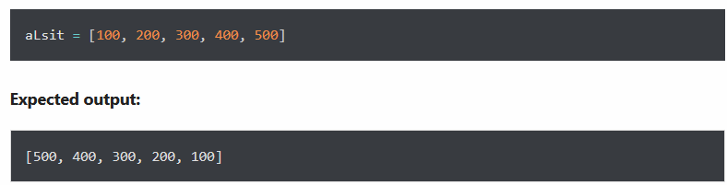

#### Exercise 2: Concatenate two lists index-wise

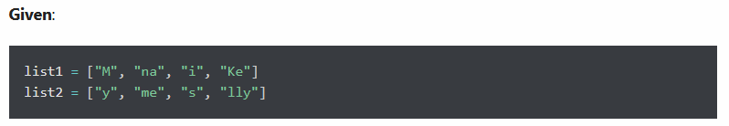

**Expected output:**



#### Exercise 3: Given a Python list of numbers. Turn every item of a list into its square

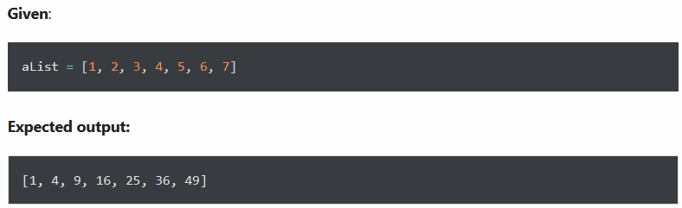

**Exercise 4: Concatenate two lists in the following order**

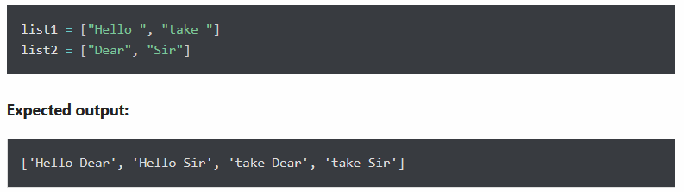

#### Exercise 5: Given a two Python list. Iterate both lists simultaneously such that list1 should display item in original order and list2 in reverse order

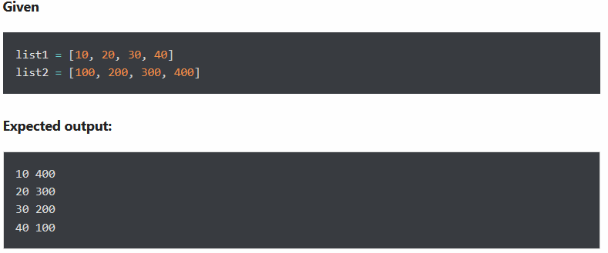

#### Exercise 6: Remove empty strings from the list of strings





**Exercise 7: Add item 7000 after 6000 in the following Python List**

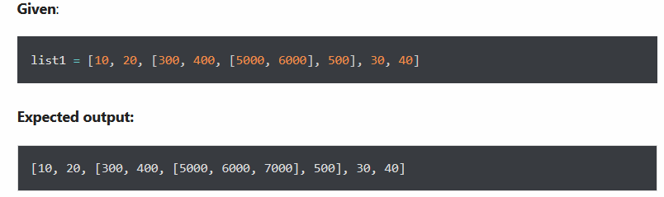

#### Exercise 8: Given a Python list, find value 20 in the list, and if it is present, replace it with 200. Only update the first occurrence of a value

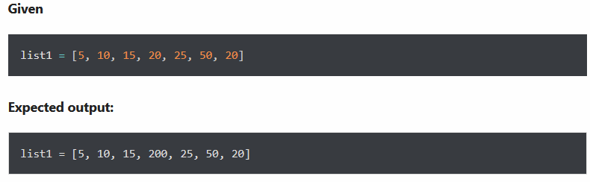

#### Exercise 9: Given a Python list, remove all occurrence of 20 from the list



**Expected output:**

